What was the Cold War All About?

VS.
Communism/Totalitarianism (USSR) | Capitalism Democracy (USA)

Causes of the Cold War
Cause 1:
Cause 2:
Cause 3:
Cause 4:

Defense Alliances
NATO | WARSAW PACT

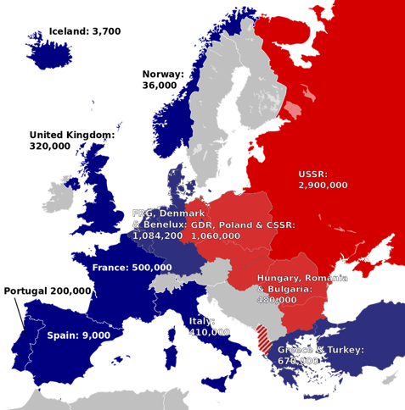

Soviet Union Characteristics
Communism:

Totalitarianism:

Motives:

United States Characteristics
Democracy:

Capitalism:

Motives:

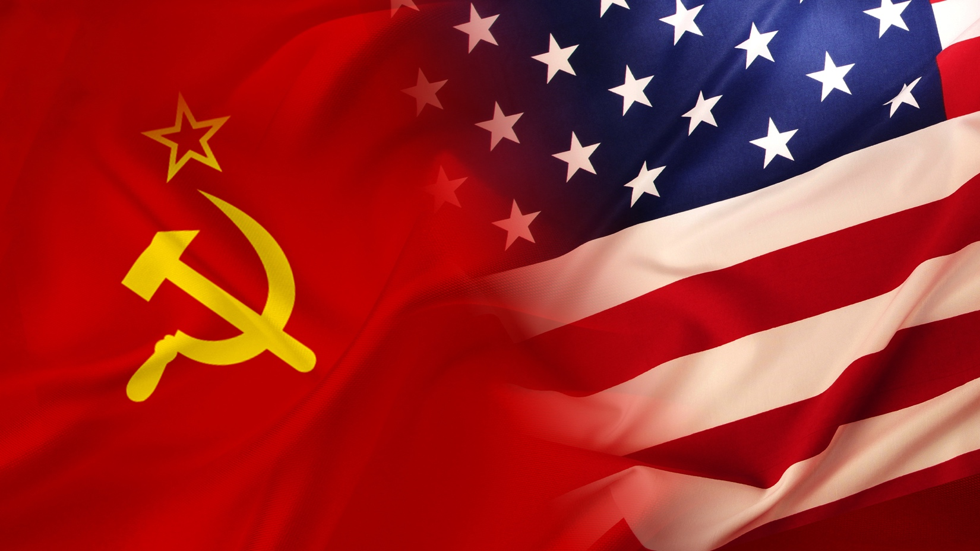

TIMELINE OF THE COLD WAR
EVENT | DESCRIPTION | YEAR
 | With the defeat of Nazi Germany imminent, the Big Three Allies meet in the Crimean resort town of Yalta from February 4-11. Roosevelt, Churchill and Stalin agree to jointly govern postwar Germany, while Stalin pledges fair and open elections in Poland.
 | On June 24, the Soviet Union makes a bid for control of Berlin by blockading all land access to the city. From June 1948 to May 1949, U.S. and British planes airlift 1.5 million tons of supplies to the residents of West Berlin. After 200,000 flights, the Soviet Union lifts the blockade.
 | On June 25, North Korean communist forces cross the 38th parallel and invade South Korea. On June 27, Truman orders U.S. forces to assist the South Koreans while the U.N. Security Council condemns the invasion and establishes a 15-nation fighting force. Chinese troops enter the conflict by year's end.
 | On October 4, the Soviet Union launches Sputnik, the first man-made satellite to orbit the Earth. In 1958, the U.S. creates the National Aeronautics and Space Administration, and the space race is in full gear.
 | On May 1, an American high-altitude U-2 spy plane is shot down on a mission over the Soviet Union. After the Soviets announce the capture of pilot Francis Gary Powers, the United States recants earlier assertions that the plane was on a weather research mission.
 | After the failed Bays of Pigs invasion, the Soviet Union installs nuclear missiles in Cuba capable of reaching most of the continental United States. After U-2 flights confirm their existence, Kennedy orders a naval blockade of Cuba on October 22 until the Soviet Union removes its missiles. On October 28, the Soviets agree to remove the missiles, defusing one of the most dangerous confrontations of the Cold War.
 | North Vietnamese patrol boats fired on the USS Mattox in the Gulf of Tonkin on August 2. On August 7, the U.S. Congress approves the Gulf of Tonkin Resolution, granting President Johnson authority to send U.S. troops to South Vietnam
 | On November 17, the first phase of Strategic Arms Limitation Talks begins in Helsinki, Finland. The finished agreement, signed by Nixon and Brezhnev in Moscow on May 26, 1972, places limits on both submarine-launched and intercontinental nuclear missiles.
 | On March 23, Reagan outlines his Strategic Defense Initiative, or "Star Wars," a space-based defensive shield that would use lasers and other advanced technology to destroy attacking missiles far above the Earth's surface. Soviets accuse the U.S of violating the 1972 Antiballistic Missile Treaty.
 | Gorbachev renounces the Brezhnev Doctrine, which pledged to use Soviet force to protect its interests in Eastern Europe. On September 10, Hungary opens its border with Austria, allowing East Germans to flee to the West. After massive public demonstrations in East Germany and Eastern Europe, the Berlin Wall falls on November 9.

