Political Stability
Britain had a stable government that supported individual political freedom, property rights, and equality of opportunity. These traits encouraged entrepreneurs to take risks in pursuit of profit.  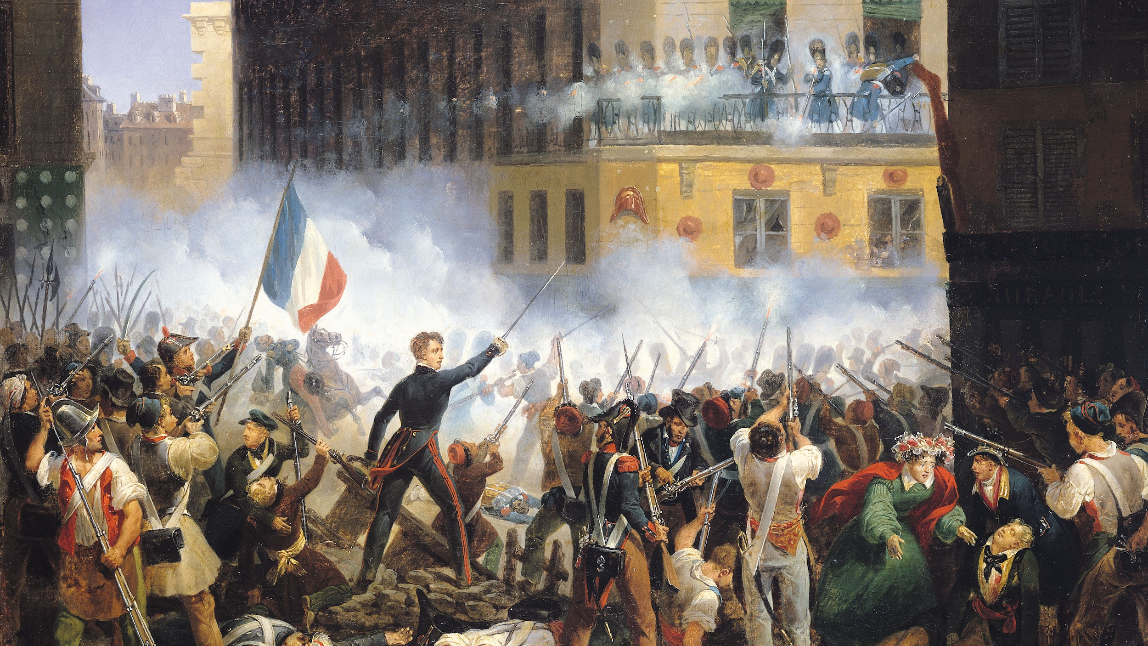  + | 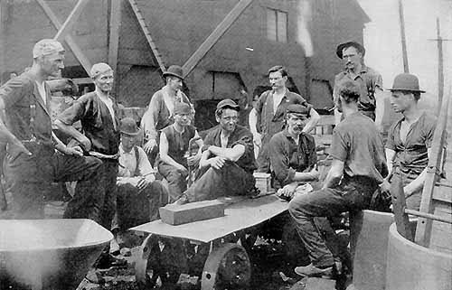 |  |  | +  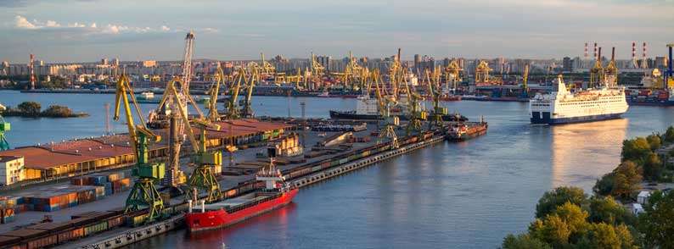  +
Put it All Together: The Factors of Industrialization are

_____________________ + _____________________ + _____________________ + _____________________ + _____________________ =

______________________________________________________!

Please Summarize your notes in a paragraph. What are the Factors of Industrialization?
Type your answer here:

