The Industrial Revolution changed the economy. But it also changed society and politics.

Industrial Labor
The domestic system took place in the home. Families could do the work with each other. The family stayed together. They could sing and eat together and work at their own speed. Also, most of the work was done during the fall and winter, when farming work was little.
In a factory, the job was much different. Factory bosses wanted people to work and work hard. Productivity was the most important thing. People worked for long hours and got very little pay. The factories were dangerous and dirty. Accidents happened all the time. People lost fingers, arms, and sometimes were killed.

Women and Children
Most of the work in the domestic system was done by women and children. At the start of the Industrial Revolution, many women and children were hired for the textile factories because the owners could pay them less than men. But still, many women lost jobs when the change from domestic to factory work happened. One reason was because society decided that factory work was too hard for women.
Children worked in textile factories and coal mines, but also worked in other factories, too. Families had to have their children work in order afford to live. As the 1800s ended, more people began to think children should not work in such dangerous places. New laws made their work hours shorter and in some countries made it illegal for children to work.

Urbanization: the growth of cities
The first factories were placed next to towns. As farm jobs went away, more people moved to towns and looked for jobs in factories. As a result, small towns grew into cities and cities grew into large cities.
Factory jobs also attracted people from other countries. More and more immigrants also made cities larger.
Cities grew so fast that the governments did not have enough housing. They built really dangerous homes that were dirty and unhealthy. There was not running water and human waste was a big problem. Thousands of people died from diseases because of the dirty conditions.

Labor Unions
Owners of factories wanted to make as much money as possible. They would pay the workers poorly and would not spend the money to make factories safer. The government liked the taxes the rich owners would give it so the government was not interested in changing the low pay and bad work conditions.
The only thing helping workers were labor unions. Labor unions are groups of workers that try to make things better for workers. Labor Unions were able to make some things better. By the early 1900s, the work week went from 14 hour days to 10 hour days. Some unions were able to get better pay for workers, too.

From Laissez-Faire to Regulation
Laissez-Faire is French for “hands off.” It meant that the government did not make laws about the economy. They kept their hands off. That is how it was in the early days of the Industrial Revolution. Owners of businesses liked laissez-faire because it meant they made more money. But the governments around the world began to see that if they did not make laws about the economy, the big businesses would do bad things which could hurt consumers, like making prices of goods too high. Governments, around 1900, began to make laws to control businesses a bit more.
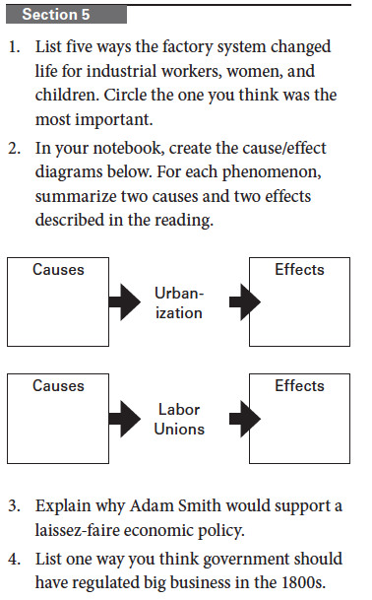
two

