7-1 Skills Practice
Multiplication Properties of Exponents

Determine whether each expression is a monomial. Write yes or no. Explain.
1. 11

2. a – b

3. $\frac{p^{2}}{r^{2}}$

4. y

5. $j^{3}$k

6. 2a + 3b

Simplify.
7. $a^{2}$($a^{3}$)($a^{6}$) 8. x($x^{2}$)($x^{7}$)

9. ($y^{2}$z)(y$z^{2}$) 10. ($l^{2}k^{2}$)($l^{3}$k)

11. ($a^{2}b^{4}$)($a^{2}b^{4}$) 12. (c$d^{2}$)($c^{3}d^{2}$)

13. (2$x^{2}$)(3$x^{5}$) 14. (5$a^{7}$)(4$a^{2}$)

15. (4x$y^{3}$)(3$x^{3}y^{5}$) 16. (7$a^{5}b^{2}$)($a^{2}b^{3}$)

17. (–5$m^{3}$)(3$m^{8}$) 18. (–2$c^{4}$d)(–4cd)

19. ${({10}^{2})}^{3}$ 20. ${(p^{3})}^{12}$

21. ${(-6p)}^{2}$ 22. ${(-3y)}^{3}$

23. ${(3pr^{2})}^{2}$ 24. ${(2b^{3}c^{4})}^{2}$

GEOMETRY Express the area of each figure as a monomial.
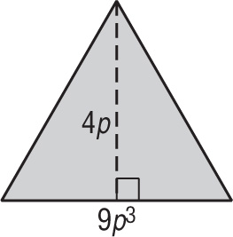
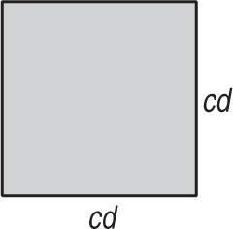
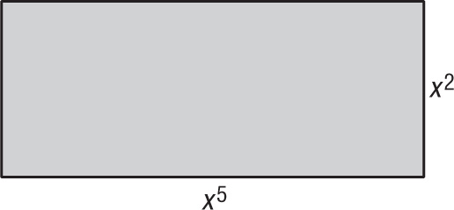
25. 26. 27.

