Hook Activity: For each scenario, decide whether the action was done out of principle or politics. You must also explain your answer.
- Principle or politics or both: politics
Explain: because he wanted the family car, not because it would be morally right

- Principle or politics or both: principle
Explain: she is showing her stance on the war by boycotting taxes

- Principle or politics or both: politic
Explain: because they want to be favored so they changed their principles/morals

- Principle or politics or both: principle
Explain: longer lunch hours for students to enjoy more

- Principle or politics or both: principle
Explain: because his conscious felt guilty

- Principle or politics or both: both
Explain: she has to do the right thing morally and politically

- Principle or politics or both: principle
Explain: empathized with student

- Principle or politics or both: both
Explain: it is morally right and a basic right to do so

Background Essay:
- What does it mean to say Johnson’s birthplace was “a long way from the White House”?
It was not expected that a person from a small place could make it to the White House.
- When and Where did Lyndon Johnson teach?
1928 in Cotulla, Texas
- Who was president when LBJ was first elected to the US House of Representatives?
FDR
- What evidence is there that Johnson was a hard worker?
Woke up at 6:00 A.M., work until early afternoon followed by a two-hour nap in his pajamas. Then it was up again at 4:00 P.M., a shower, a fresh change of clothes, and work until midnight or beyond.
- In his earlier years in Congress, what was Johnson’s position on national civil-rights law?
Job of states
- How did Johnson get to the President of the US?
President Kennedy assassinated, Johnson VP became president
- What were 3 of the important rights guaranteed by the Civil Rights Act of 1964?
Voting rights, strengthened equal employment opportunity, and right of public facilities
- Define each of the following:
  - Majority leader - head of the majority party in the legislative body

  - Civil rights - rights of citizens to political and social freedom of equality

  - Lynching - kill by hanging

  - Poll tax - a tax on adult

  - Watered-down - diluted with water

Document A
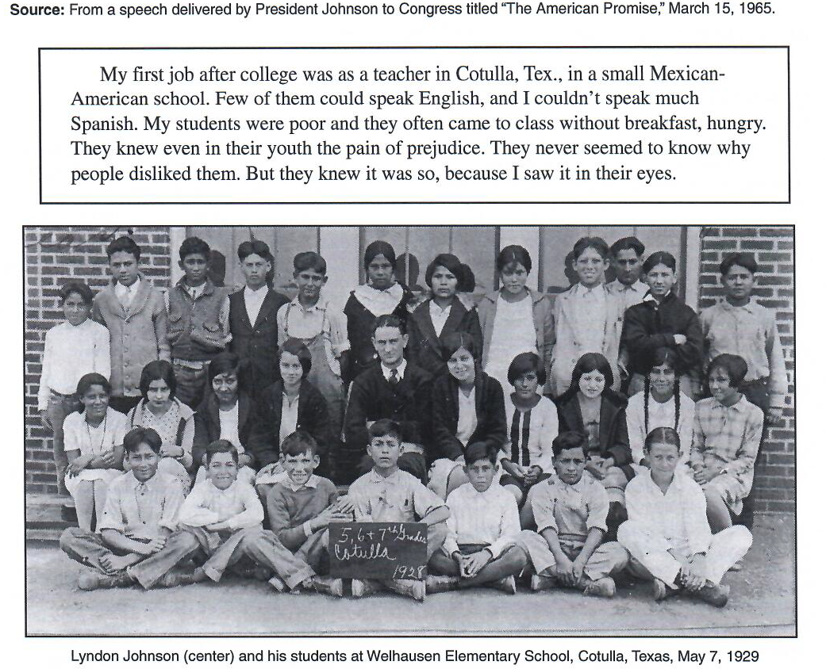

- Who are the students in this photograph?
Johnson’s students
- How are the students dressed? What does that tell you about them and their families?
They are dressed in fine but sullied clothes. Families must be poor but making ends meet.
- What are some of the life difficulties they faced?
Prejudice/judgment from people
- Which parts of the Civil Rights Act of 1964 (see the end of Background Essay) might have helped Johnson's students overcome these difficulties?
strengthened equal employment opportunity, and right of public facilities
- How can this document be used to help answer the question “Did LBJ sign the Civil Rights Act of 1964 because of politics or out of principle?
It can define why he chose to sign the civil rights act. He empathized and sympathized with his students and wanted them to have a better life.

