8-4 Skills Practice
Distributions of Data

1. TESTING SITES The total number of students taking the SAT at a sample of testing centers is shown.

Number of Students
105, 86, 98, 112, 92, 72, 102, 96, 112, 76, 117, 107, 88, 104, 90, 68, 105, 82,
75, 115, 97, 106, 82, 64, 103, 58, 96, 102, 118, 95, 87, 102, 81, 116, 97, 110

a. Create a histogram. Then describe the shape of the distribution.
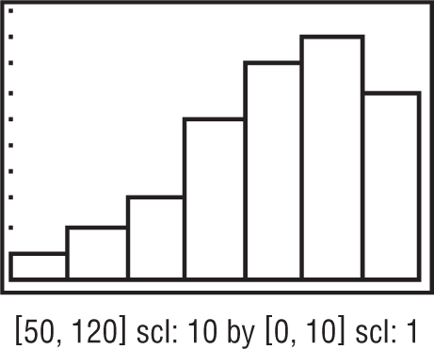

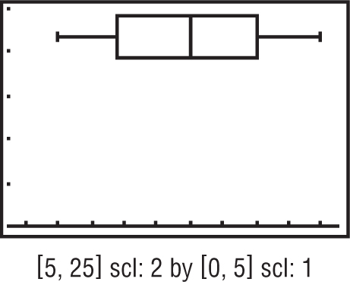

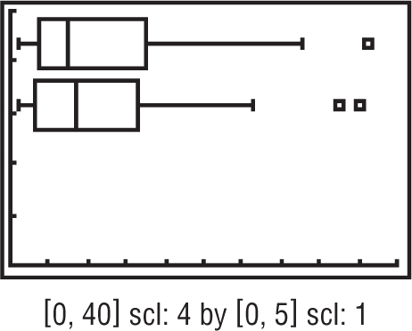

b. Describe the center and spread of the data using either the mean and standard deviation or
the five-number summary. Justify your choice.

2. BARBER A barber keeps track of the total number of customers he has each day for a sample of days.

Number of Customers
16, 18, 22, 10, 24, 13, 14, 22, 16, 20, 11,
20, 18, 10, 19, 12, 14, 20, 11, 8

a. Create a box-and-whisker plot. Then describe the
shape of the distribution.

b. Describe the center and spread of the data using either the mean and standard deviation or
the five-number summary. Justify your choice.

3. OLYMPICS The medal counts for the 2002 and 2010 Winter Olympics are shown.

2002
37, 3, 5, 2, 30, 11, 5, 1, 9, 14, 26, 11, 6,
3, 15, 1, 3, 11, 3, 23, 5, 8, 16, 3, 6, 1
2010
3, 8, 1, 25, 2, 34, 2, 3, 11, 13, 7, 17,
11, 4, 2, 8, 3, 13, 17, 7, 4, 36, 2, 1

a. Construct a box-and-whisker plot for each set of data.
Then describe the shape of each distribution.

b. Compare the distributions using either the means and standard deviations or the
five-number summaries. Justify your choice.

