CAUSES OF THE RUSSIAN REVOLUTION
CAUSE ONE: 19TH CENTURY RUSSIA  DATE: _______________________________  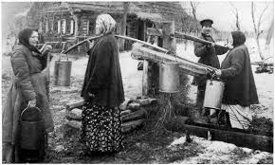 | CAUSE TWO: BLOODY SUNDAY  DATE: _______________________________  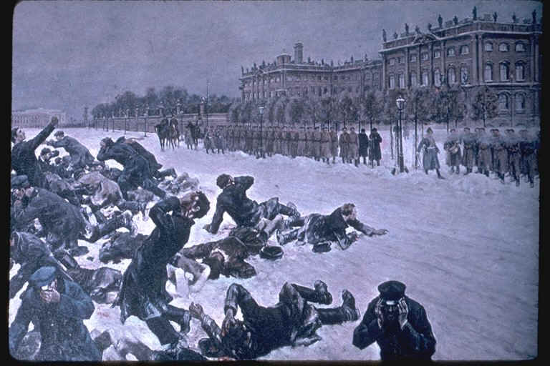 | CAUSE THREE: WWI BEGINS  DATE: _______________________________  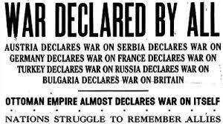
- What family controlled the Russian Empire during the 19th century?  - How did most people in Russia make their living in the 19th century?  - When was serfdom finally abolished in Russia? | - What happened to the people at the Winter Palace when they asked the Czar for help?  Use DOCUMENT A to answer questions 5 and 6.  - What are two specific complaints the people had in their petition?  - What are two specific things the people asked for in their petition? | - With whom did Russia ally before World War I began?  Use DOCUMENT B to answer question 8.  - What reason do the Serbs give to Russia for needing help?  - Why were Russians at home angry about the war?
CAUSES OF THE RUSSIAN REVOLUTION
CAUSE FOUR: RASPUTIN AND THE CZARINA  DATE: _______________________________  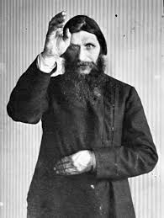 | CAUSE FIVE: REVOLUTIONS OF MARCH, 1917  DATE: _______________________________  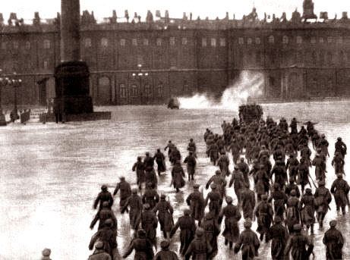 | CAUSE SIX: THE BOLSHEVIKS TAKE POWER  DATE: _______________________________  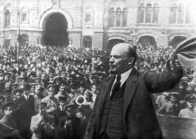
- Who did Czar Nicholas leave in control of the country when he went to war?  - Why did Rasputin have so much influence over the Czarina?  Use DOCUMENT C to answer question 12.  - Why were the Czarina’s advisors concerned about her relationship with Rasputin?  Use DOCUMENT D to answer question 13.  - What did it take to kill Rasputin? | - What did workers do to show they were unhappy in 1917?  - How did troops react to the violence?  - What does it mean to abdicate the throne?  - Why did Nicholas II abdicate his throne?  - To whom did Nicholas leave his throne? | - Who were the Bolsheviks?  - Why did Communism appeal to poor people in Russia?  - Who was the leader of the Communist party in Russia? What did he promise the Russians?  - After the Bolsheviks took control of St. Petersburg, the Russian Civil War began. Who were the two sides in that war?
EFFECTS OF THE RUSSIAN REVOLUTION
EFFECT ONE: RUSSIA WITHDRAWS FROM WWI  DATE: _______________________________  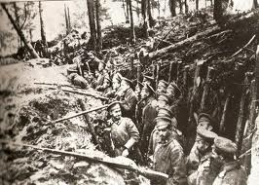 | EFFECT TWO: DEATH OF THE ROMANOVS  DATE: _______________________________  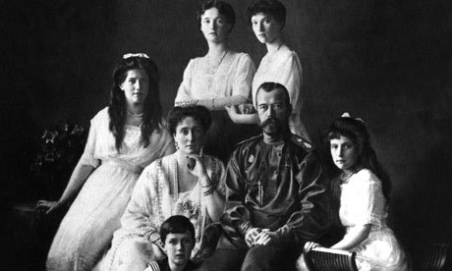 | EFFECT THREE: CREATION OF THE SOVIET UNION  DATE: _______________________________  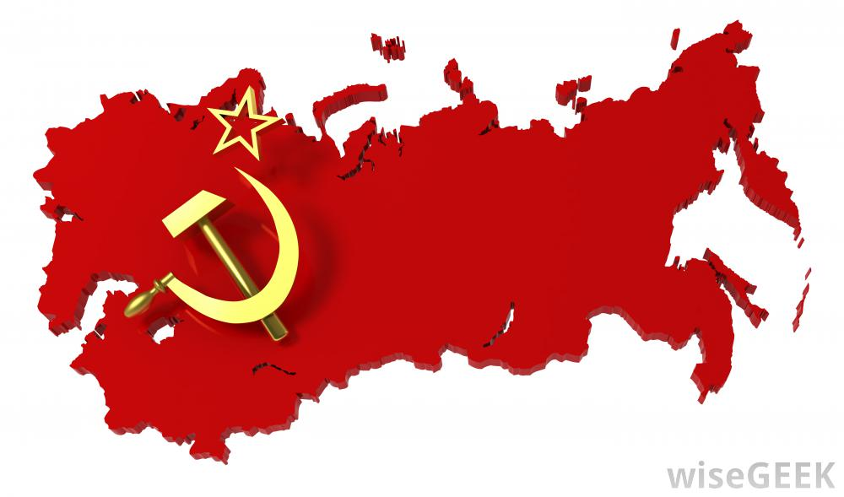
- Why did the Russians withdraw from World War I?  Use DOCUMENT F to answer questions 24 and 25.  - What was the purpose of the Treaty of Brest-Litovsk?  - What did the Russians lose in the Treaty of Brest-Litovsk? | - Why was the royal family moved to Ekaterinburg?  - What happened to the royal family?  Use DOCUMENT G to answer questions 28 and 29.  - According to the document, who was the last of the royal family to die in the murder?  - Why do you think the royal family was executed? | - What was the new name of Russia under Lenin?  - What additional countries did the new empire include?  - What are two “nicknames” for the country?

CAUSE ONE: 19TH CENTURY RUSSIA
19TH CENTURY RUSSIA In the 19th century, Russia was a vast, multinational empire controlled by the Romanov Dynasty. A dynasty is when control of a country is passed from family member to family member. For centuries, Russia was relatively isolated from the affairs of Western Europe due to their cold climates and long distances. They were a strongly agricultural country who still relied on the principals of serfdom to plant crops. This policy of tying the peasants to the land had long since been abolished in the rest of Europe and prevented Russia from advancing. Serfdom was finally abolished in 1861.
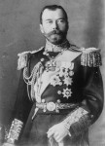
NICHOLAS II TAKE CONTROL 1894 Nicholas II had ruled Russia as Czar since the death of his father in 1894. Like his father, Nicholas wanted an autocratic rule in which he alone made all the laws and determined all foreign policy. When he took control, Russia was very far behind the industrial production of the Western European countries such as Britain and Germany. Nicholas increased industrial production in Russia but at the same time created a larger class of urban poor. Most people in Russia, however, still lived on farms.

CAUSE TWO: BLOODY SUNDAY
BLOODY SUNDAY JANUARY 9, 1905 The urban poor worked in factories for long hours, horrible conditions and little pay. In 1905, they asked the Czar for help by presenting a petition to the Winter palace. The Czar was not at home and his generals ordered the troops to open fire on the people. Over 500 unarmed people were killed in an incident that became known as Bloody Sunday. The Czar was forced to give up some of his power to a legislative branch called the Duma.

DOCUMENT A: Petition Prepared for Presentation to Nicholas II on "Bloody Sunday" (January 9, 1905)
Sovereign!
We, workers and inhabitants of the city of St. Petersburg ... our wives, children, and helpless old parents, have come to you, Sovereign, to seek justice and protection. We are impoverished and oppressed, we are burdened with work, and insulted. ...And we have suffered, but we only get pushed deeper and deeper into a gulf of misery, ignorance, and lack of rights ...And so we left our work and declared to our employers that we will not return to work until they meet our demands. We do not ask much; we only want that without which life is hard labor and eternal suffering....to reduce the working day to eight hours ... to increase the wages of unskilled workers and women to one ruble per day; to abolish overtime work; to provide medical care attentively and without insult; to build shops so that it is possible to work there and not face death from the awful drafts, rain and snow.

CAUSE THREE: WWI BEGINS
WORLD WAR ONE BEGINS 1914 At the turn of the twentieth century, Europe was in an increasingly complex situation. Countries like Austria and Germany seemed to want to grow bigger and bigger and other countries like France and Britain built up their armies to be able to defend themselves. Russia chose to ally themselves with the French and British and at the same time they formed an alliance with another Slavic nation, the small newly independent nation of Serbia.
In June 1914, a Serbian nationalist named Gavrilo Princip shot and killed the archduke to the Austrian throne setting of a series of events that started World War One. Faced with a very angry and demanding Austria, Serbia looked to Russia for help. Nicholas agreed to back Serbia in a war against the Austrians...and World War One began.
DOCUMENT B: Serbian telegram to Russian Czar July 1914
We have been given too short a limit . . . We can be attacked after the expiration of the time-limit by the Austro-Hungarian Army which is concentrating on our frontier...It is impossible for us to defend ourselves, and we supplicate your Majesty to give us your aid as soon as possible.
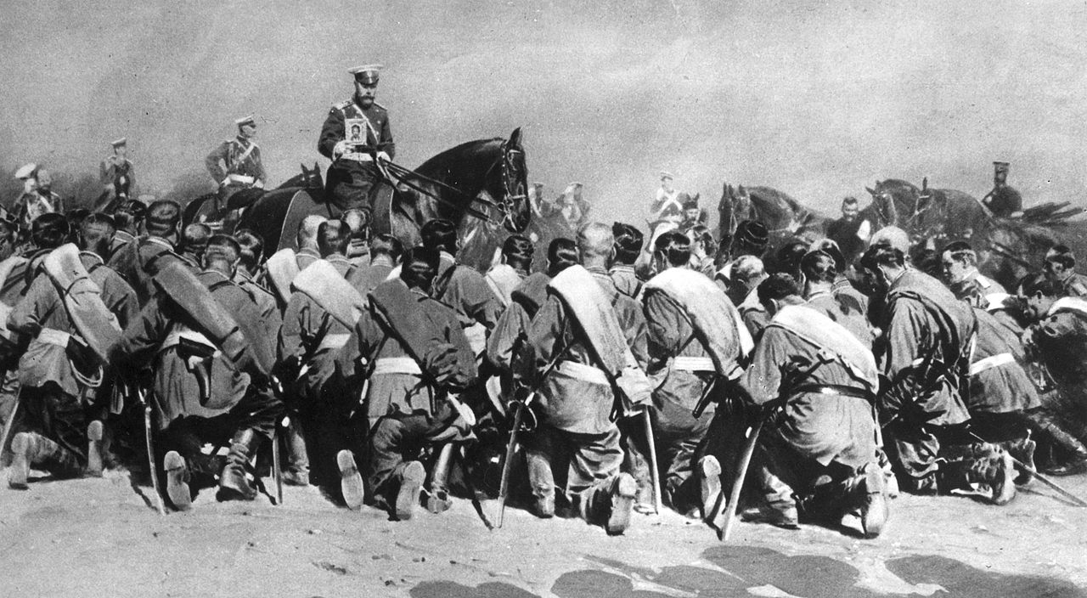
CZAR NICHOLAS TAKES COMMAND OF ARMY 1915 Russian troops were not as strong as the Western European industrial nations of Germany and Austria. The war went badly with many Russian casualties. At home, citizens were becoming more and more upset and angry over the deaths of their sons and fathers. Over fifteen million men were drafted into the Russian army from farms and factories. Food and other supplies were in desperate need for the people. Nicholas finally decided to go to the Eastern Front and lead his own troops.
CAUSE FOUR: RASPUTIN AND THE CZARINA
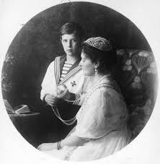
RASPUTIN AND THE CZARINA 1916: The decision by the Czar to leave St. Petersburg to coordinate battle plans in World War I proved to be a fatal one. It caused him two major problems. First, his presence at the front made it even easier to blame him. Second, he left the control of his government in the hands of his wife, the Czarina Alexandra who proved to be ill-prepared to lead the country under the influence of Gregory Rasputin. The Czarina was convinced that only Rasputin could save the life of her young son, Alexi. Like many other members of the Czarina's family. Alexi suffered from a life threatening genetic disease. False rumors soon spread that Rasputin was the Czarina's lover. Led by a cousin of Nicholas' young nobles became increasingly concerned about Rasputin's influence over the Czarina and murdered him. The damage to the reputation of the royal family, however, remained.
Document C: Alexander Kerensky, Russia and History's Turning Point (1965)
The Czarina’s blind faith in Rasputin led her to seek his counsel not only in personal matters but also on questions of state policy. General Alekseyev, held in high esteem by Nicholas II, tried to talk to the Czarina about Rasputin, but only succeeded in making an implacable enemy of her. General Alekseyev told me later about his profound concern on learning that a secret map of military operations had found its way into the Czarina’s hands. But like many others, he was powerless to take any action.

Document D: Assassination of Rasputin, 29 December 1916
A small table was spread with cakes and rare wines - three kinds of the wine were poisoned and so were the cakes. We were seized with an insane dread that this man was inviolable, that he was superhuman, that he couldn't be killed. It was a frightful sensation. He glared at us with his black, black eyes as though he read our minds and would fool us. (CONTINUED)
And then after a time he rose and walked to the door. We were afraid that our work had been in vain. Suddenly, as he turned at the door, someone shot at him quickly. With a frightful scream Rasputin whirled and fell, face down, on the floor. The others came bounding over to him and stood over his prostrate, writhing body.
It was suggested that two more shots be fired to make certain of his death, but one of those present said, "No, no; it is his last agony now." Suddenly we heard a strange and unearthly sound behind the huge door that led into the library. The door was slowly pushed open, and there was Rasputin on his hands and knees, the bloody froth gushing from his mouth, his terrible eyes bulging from their sockets. With an amazing strength he sprang toward the door that led into the gardens, wrenched it open and passed out.
As he seemed to be disappearing in the darkness, F. Purishkevich, who had been standing by, reached over and picked up an American-made automatic revolver and fired two shots swiftly into his retreating figure. We heard him fall with a groan, and later when we approached the body he was very still and cold and - dead.
We bundled him up in a sheet and carried him to the river's edge. Ice had formed, but we broke it and threw him in.
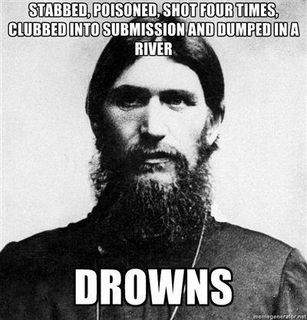

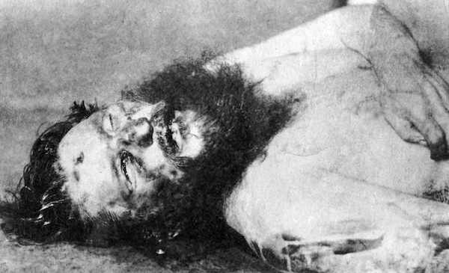
CAUSE FIVE: REVOLUTIONS OF MARCH, 1917
REVOLUTION OF MARCH 1917 While Nicholas was away leading the war, the situation in St. Petersburg grew more and more serious. Workers began to strike and soldiers began to desert their posts. Politicians from all over the world advised Nicholas to begin reform movements and bring democratic change to Russia but Nicholas ignored them. He stayed away from St. Petersburg at the front lines. Rioters were breaking into stores to steal food and supplies. Troops refused to keep order and they joined the rioters. Eventually, the Czars' wife and children were held prisoner. Faced with this, the Czar was finally forced to abdicate which means give up his power.
Document E Decree of Abdication March 15, 1917
…In agreement with the Imperial Duma, We have thought it well to renounce the Throne of the Russian Empire and to lay down the supreme power. As We do not wish to part from Our beloved son, We transmit the succession to Our brother, the Grand Duke Michael Alexandrovich, and give Him Our blessing to mount the Throne of the Russian Empire.
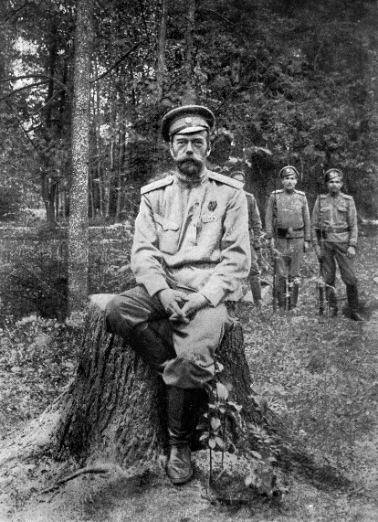
We direct Our brother to conduct the affairs of state in full and inviolable union with the representatives of the people in the legislative bodies on those principles which will be established by them, and on which He will take an inviolable oath. (SIGNED) NICHOLAS II
PROVISIONAL GOVERNMENT TAKES OVER: SPRING 1917 When Nicholas abdicated, he left his power to his brother, who promptly refused to take it. Leaders of the revolution attempted to set up a provisional or temporary government. Their intent was to set up a government based upon the democratic principles of the Western world. The Duma was reinstated and new leaders were chosen. Despite their good intentions, however, the provisional government was struggling to keep control.

CAUSE SIX: THE BOLSHEVIKS TAKE POWER
THE BOLSHEVIKS RETURN SPRING 1917 Bolsheviks were the communist followers of Karl Marx in Russia. Factory workers who had been treated so badly during the early industrial period were looking for a change. The gap between the rich and the poor in Russia was huge. Communism appealed to the poor who had little to lose. The leader of the communist party in Russia was Vladimir Lenin. Due to the threat he represented to the Czar, Lenin had been in exile in Western Europe during the first part of the war. The German government saw Lenin as a means to upset the delicate balance in Russia and helped him to escape back to St. Petersburg. With the provisional government struggling, Lenin saw this as a chance to take control for communism. Lenin and the Bolsheviks promised war torn Russians the three things needed most, Peace, Land and Bread.
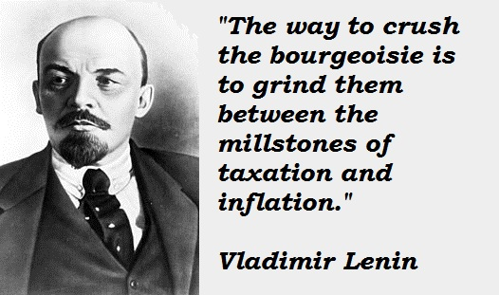
THE BOLSHEVIKS TAKE POWER: REVOLUTION OF OCTOBER 1917 In October 1917, Lenin and his followers began a take-over of St. Petersburg. Bolsheviks faced little opposition in taking over government buildings. The provisional government quickly collapsed and its leaders fled the city. The Bolsheviks began taking charge of Russia and immediately began a Civil War between the Red Bolshevik Army and the White Anti-Bolshevik forces.

EFFECT ONE: RUSSIA WITHDRAWS FROM WWI
END OF WORLD WAR ONE FOR RUSSIA MARCH 1918. By 1917, Germany and Russia were stuck in a stalemate on the Eastern Front of World War I. At the time, the Russian economy nearly collapsed under the strain of the war effort. The large war casualties and food shortages in the major urban centers brought about civil unrest. Anxious to end Russian involvement in World War One, Lenin met with their former enemies, Austria, Germany and The Ottoman Turks. In March of 1918, the Russians signed a separate peace agreement called the Treaty of Brest Litovsk with the Germans, Austrians and Ottoman Empires. With little to bargain, Russians lost territory including Poland, Finland and the Ukraine. The World War continued until November 1918 when the Germans, Austrians and Ottomans surrendered. The Russians were to gain much of this lost territory back over the next few years.
Document F: Primary Documents: Treaty of Brest-Litovsk, 3 March 1918
Germany, Austria-Hungary, Bulgaria, and Turkey, for the one part, and Russia, for the other part, declare that the state of war between them has ceased.
They are resolved to live henceforth in peace and amity with one another... The Ukrainian territory will, without delay, be cleared of Russian troops and the Russian Red Guard. Estonia and Livonia will likewise, without delay, be cleared of Russian troops and the Russian Red Guard... Finland and the Aaland Islands will immediately be cleared of Russian troops and the Russian Red Guard, and the Finnish ports of the Russian fleet and of the Russian naval forces....
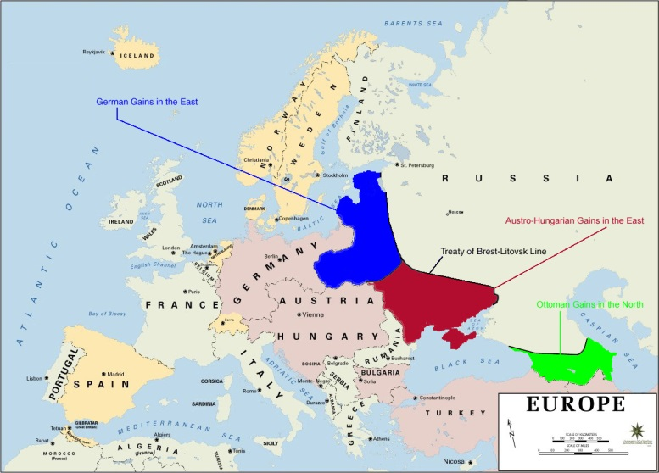
EFFECT TWO: DEATH OF THE ROMANOVS
DEATH OF NICHOLAS II AND HIS FAMILY JULY 1918 Upon his abdication to the provisional government, the Czar and his family were kept under house arrest. When the Bolsheviks did take power in October 1917, talk of putting Nicholas on trial increased. Fearful that the White Army was advancing to set Nicholas free, the royal family was moved again and finally ended up in the town of Ekaterinburg in 1918. Again, the White Army and possible rescue advanced on the town. Nicholas and his family were awakened in the middle of the night, moved to the basement and shot. Their bodies were burned with acid and thrown down a well. Eight days after the executions, the town of Ekaterinburg was captured by the White Army.
DOCUMENT G: DEATH OF NICHOLAS II AND HIS FAMILY
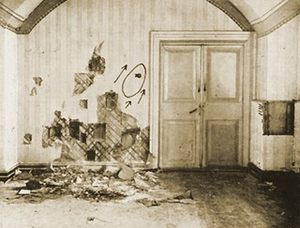
Yurovsky said to me, 'We must shoot them all tonight; so notify the guards not to be alarmed if they hear shots.' I understood, therefore, that Yurovsky had it in his mind to shoot the whole of the Tsar's family, as well as the doctor and the servants who lived with them, but I did not ask him where or by whom the decision had been made... and upon entering the room where the execution had taken place, I saw that all the members of the Tsar's family were lying on the floor with many wounds in their bodies. The blood was running in streams. The doctor, the maid and two waiters had also been shot. When I entered the heir (Alexi) was still alive and moaned a little. Yurovsky went up and fired two or three more times at him. Then the heir was still."
EFFECT THREE: CREATION OF THE SOVIET UNION
CREATION OF THE UNITED SOVIET SOCIALIST REPUBLIC/ THE USSR 1922 Led by Vladimir Lenin, Russia was expanded to include several smaller territories such as Armenia, Azerbaijan, Belarus, Estonia, Georgia, Kazakhstan, Kyrgyzstan, Latvia, Lithuania, Moldova, Russia, Tajikistan, Turkmenistan, Ukraine, and Uzbekistan. These countries adopted the name United Soviet Socialist Republic or USSR as a sign of their commitment to communist ideas. People also call this the Soviet Union. The word Soviet represented the workers unions in Russia.
END OF THE RUSSIAN CIVIL WAR 1923. The Russian Civil War lasted from 1917 to 1923 between the Red Bolshevik forces and those that opposed them, the White Army. The White Army was aided by nationalists groups such as the Ukrainians and for a time, the US, French and British forces of World War One. Despite this assistance, the Red Army and the Bolsheviks eventually won. The Civil War devastated Russia and over 15 million people died. That number was in addition to the 5 million people who died in World War One. The country was exhausted and near ruin. Roads, factories, farms and railroads were destroyed. Famine and drought in the early 1920's only made this worse.
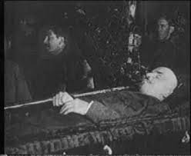
DEATH OF LENIN There were several assassination attempts against Lenin during the Revolution and during his rule of Russia. The most serious of which was in 1918 when a bullet pierced his jaw and neck. It was decided that it was too dangerous to remove the bullets so they were left in his body. His health declined at this point and he later suffered a series of strokes that eventually left him bedridden and unable to speak. Lenin's death in 1924 brought a new leader to the USSR. Josef Stalin was harsh and cruel and established total control within the communist country. He ruled the USSR for over thirty years.

Russian Revolution Vocabulary
Term | Definition | Possible Answers
 | when people are treated harshly and unfairly by their government | - dynasty  - serfdom  - abolished  - petition  - Bloody Sunday  - Duma  - impoverished  - oppressed  - Gregory Rasputin  - St. Pertersburg  - abdicate  - provisional  - Bolsheviks  - Vladimir Lenin  - exile  - civil unrest  - United Soviet Socialist Republic (USSR) or Soviet Union  - Russina Civil War  - Josef Stalin
 | when control of a country is passed from family member to family member
 | the name given to Russia by the communists
 | the event where troops fired on protestors and killed over 500
 | when a person is forced to leave their country for political reasons
 | give up power
 | the leader of the Bolsheviks
 | communist followers fo Karl Marx in Russia
 | policy of tying the peasants to the land
 | poor
 | legislative branch
 | temporary
 | when civilians are mad and protest or riot
 | the war for control of Russia after Nicholas II gave up the throne
 | a written request for change
 | harsh and crule leader of USSR after Lenin died
 | a Russian holy man whom the Czarina thought was the only man who could save her son’s life
 | capital city of Russia
 | put to an end

